# [**Installing Jenkins on Docker with Port Mapping and Persistent Data Across Containers**](https://app.tango.us/app/workflow/2b8b1ddf-88e1-435c-abb2-d385cb5cc312?utm_source=magicCopy&utm_medium=magicCopy&utm_campaign=workflow%20export%20links)

**Creation Date:** April 2, 2023

**Created By:** Curiosity

### **1. Visit the docker hub page to find the latest version of jenkins**

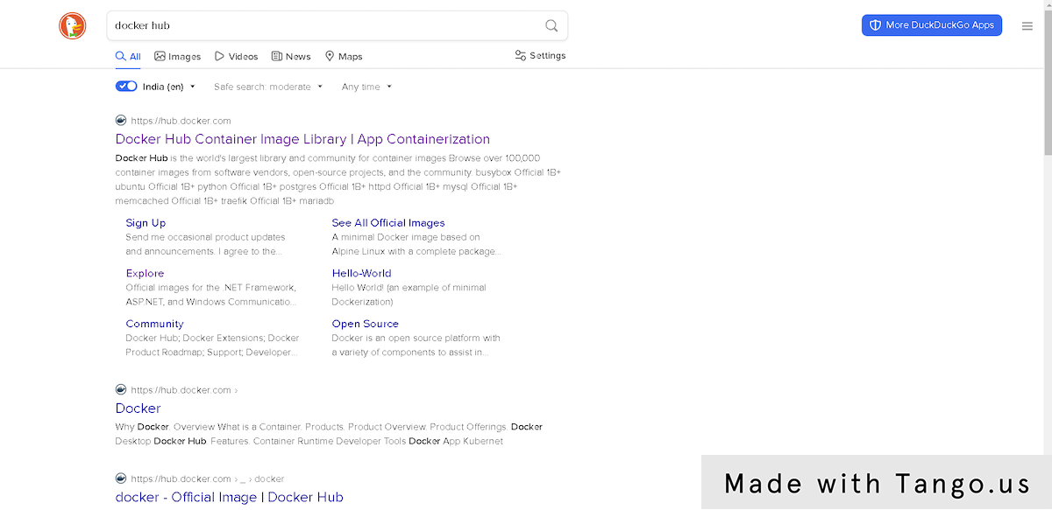

### **2. Click on Explore…**

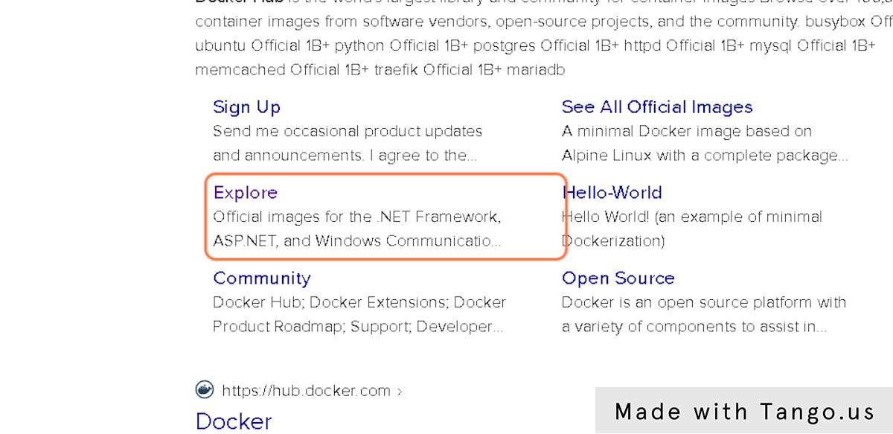

### **3. Type "jenkins"**



### **4. Click on jenkins/jenkins**

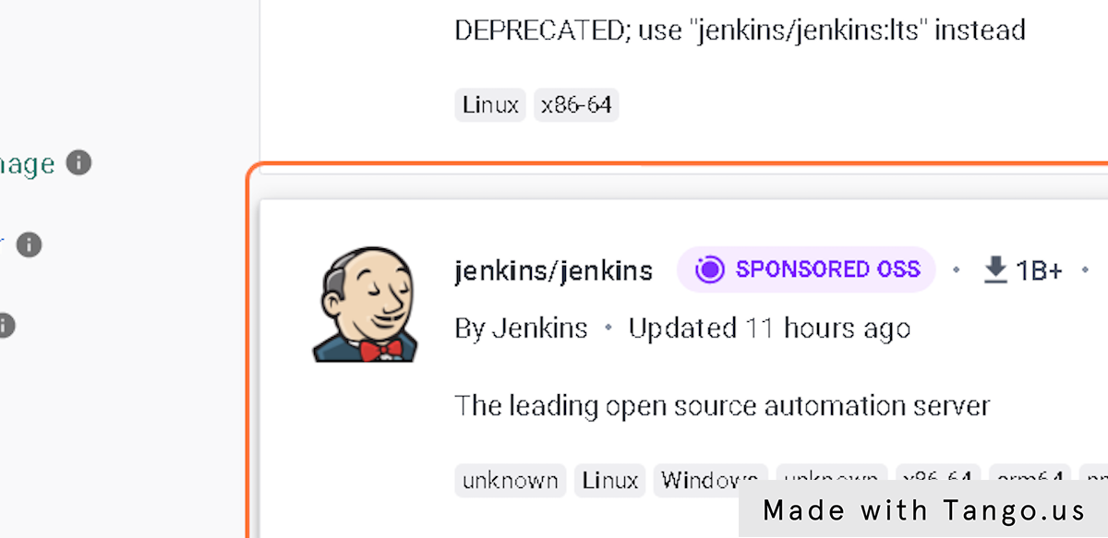

### **5. Copy "docker pull jenkins/jenkins:lts-jdk11"**

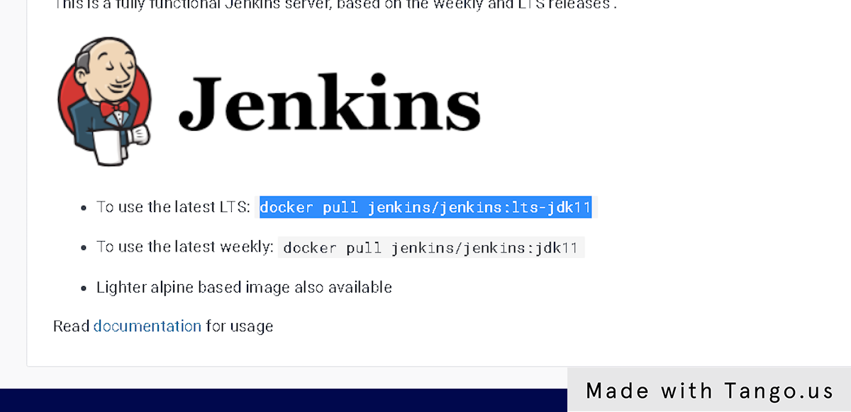

### **6. Pull the Docker image of Jenkins and run it in detached mode**

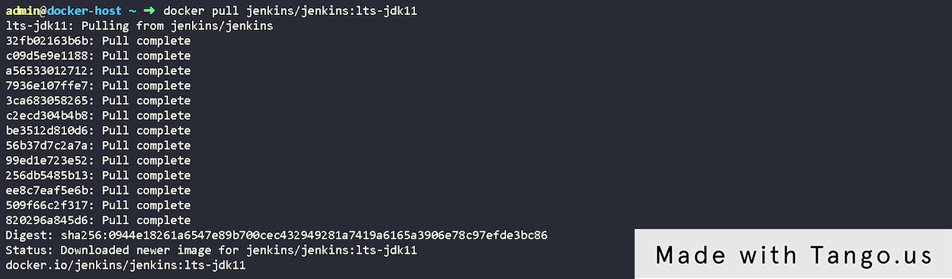

### **7. check the local machine IP, so that we can verify will it be reachable on specific port Hostname -I**

### **8. Since it is reachable only in container internal IP address, we can try to map the port of container internal port to our docker host port**

### **9. Let's run it in detached mode**

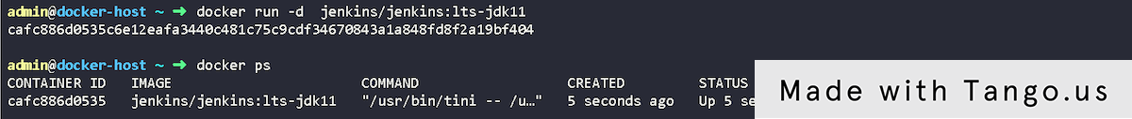

### **10. Now since the container is running, let's try to map the port from container port to docker host port. Follow the steps below: Click on jenkins/jenkins…**

**Now since the container is running, let's try to map the port from container port to  docker host port. Follow the steps below:
Click on jenkins/jenkins…**

### **11. In the same page below click on documentation**

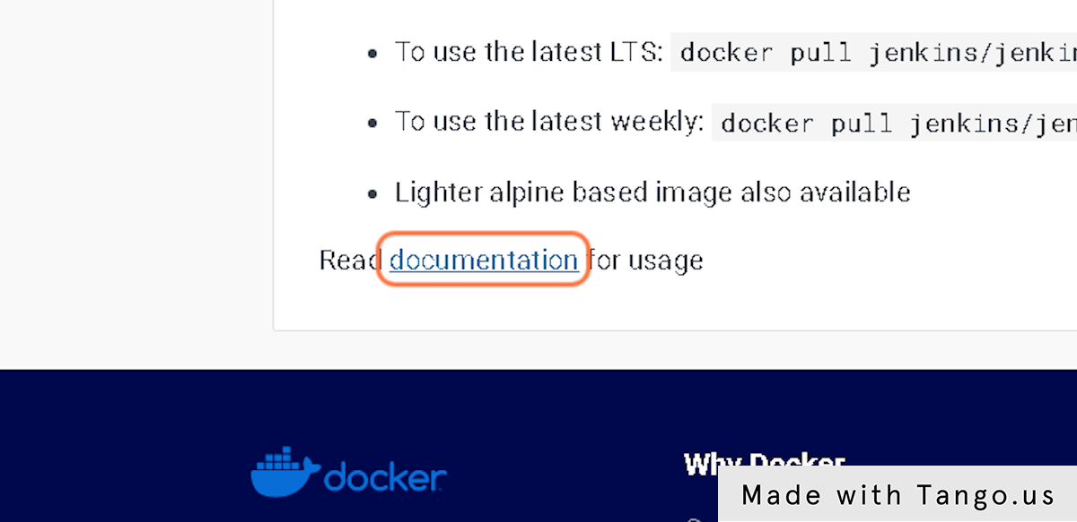

### **12. Copy docker run -p 8080:8080 -p 50000:50000 --restart=on-failure jenkins/jenkins:lts-jdk11**

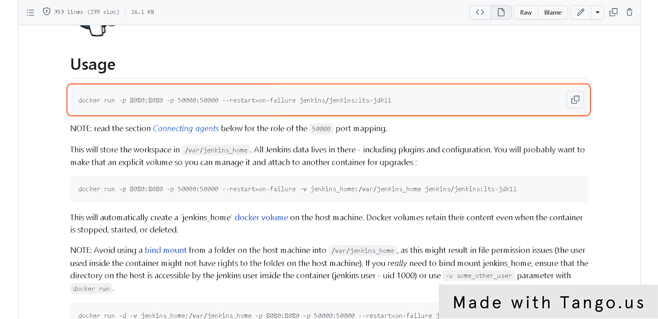

### **13. Run the copied command and check the container status**

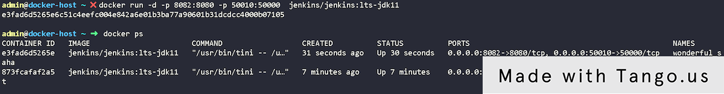

### **14. You can see message as Please wait while Jenkins is getting ready to work ...…**

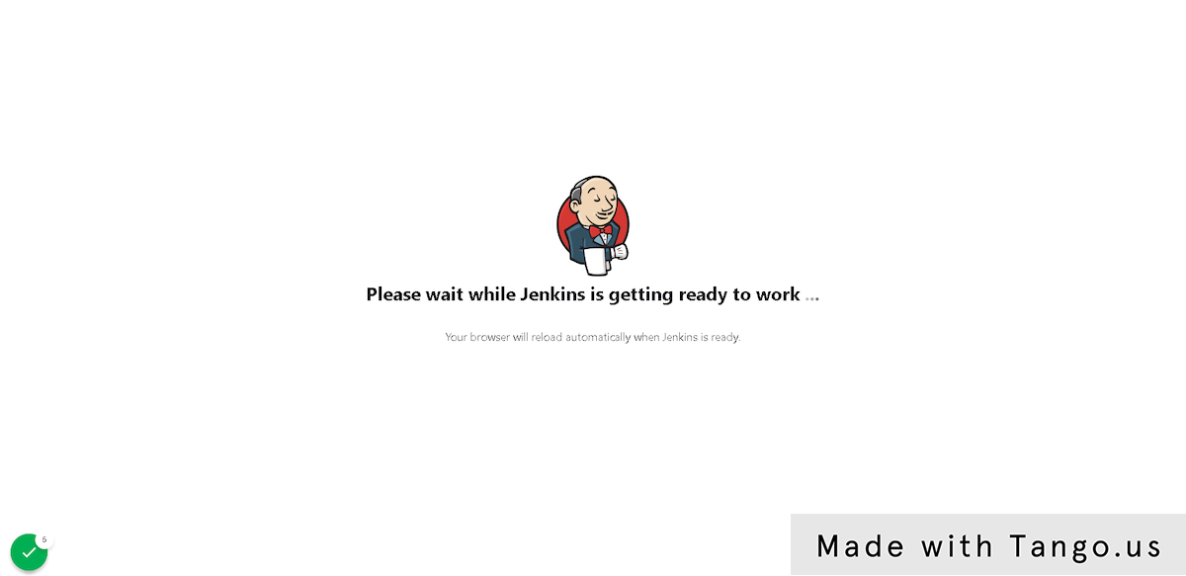

### 

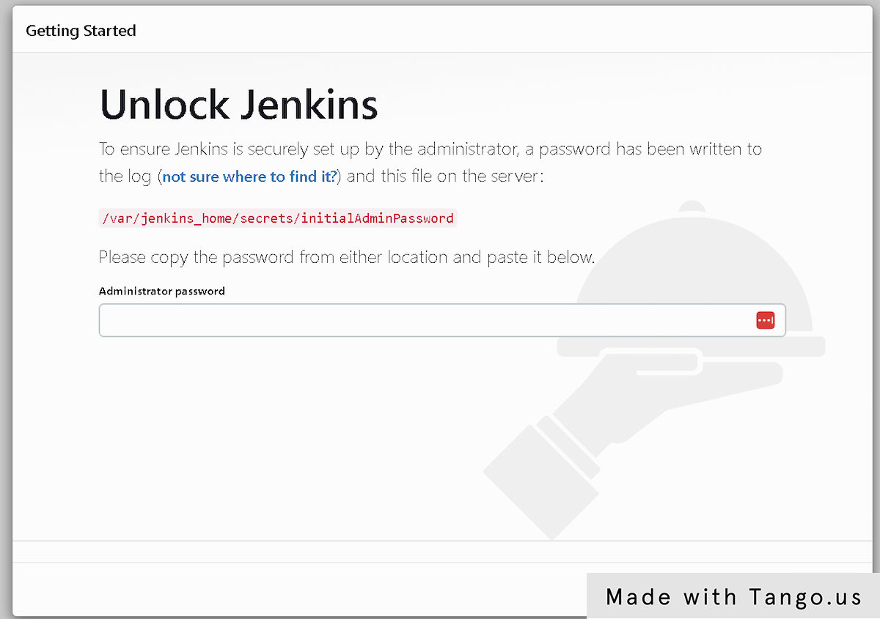

### **16. docker exec cat /var/jenkins_home/secrets/initialAdminPassword**

### **17. edit the command depending on your container ID**

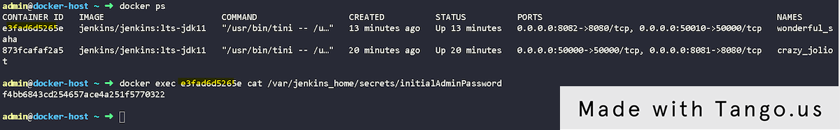

### **18. Now you can log in with an administrator password and configure the jobs like the below(you can set up your user account)**

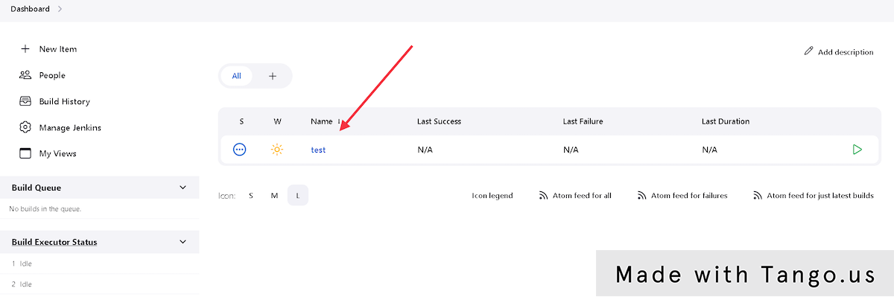

### **19. If we try to start a new container, we will again have to configure the same above steps again. Let's try to run one new container with the volume mapping**

### **20. Copy docker run -p 8080:8080 -p 50000:50000 --restart=on-failure -v jenkins_home:/var/jenkins_home jenkins/jenkins:lts-jdk11…**

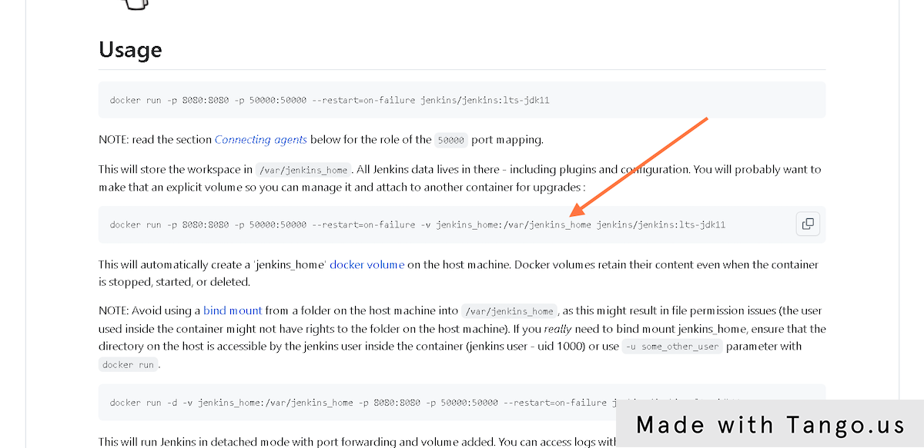

### **21. I have created the Jenkins_files under the root directory and configured this to run it on port 8085 and mapped the volume to /root/jenkins_files**

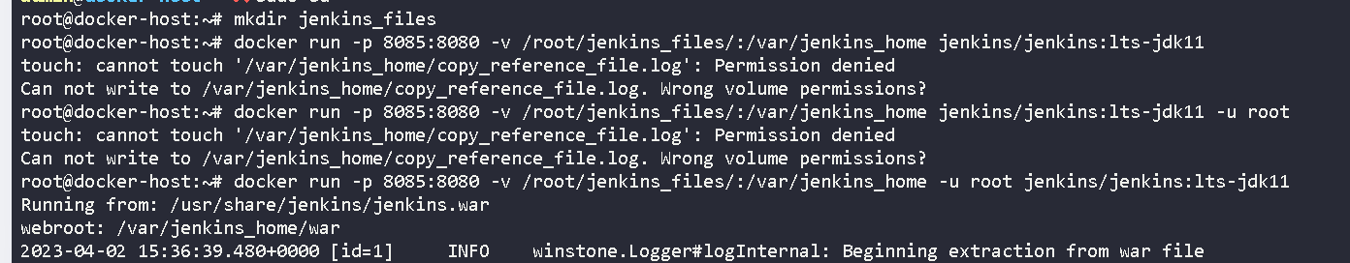

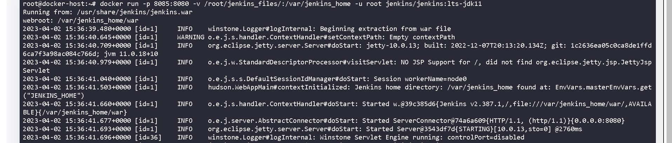

### **22. open port 8085 and validate if it working**

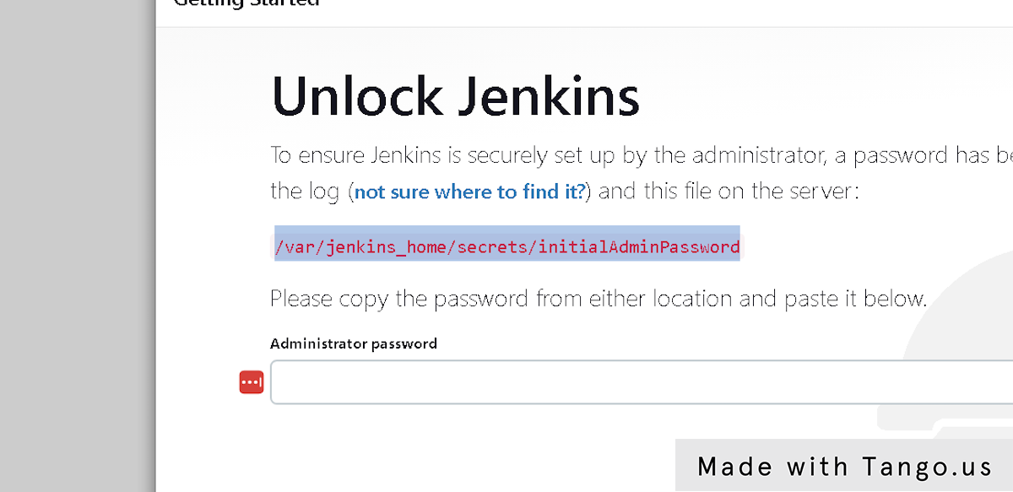

### **23. Enter the password as we discussed in earlier steps and continue**

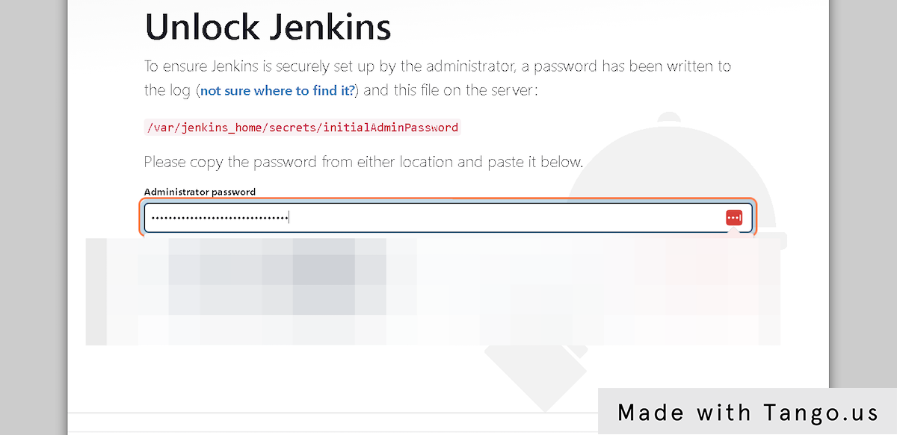

### **24. Click on Install suggested plugins…**

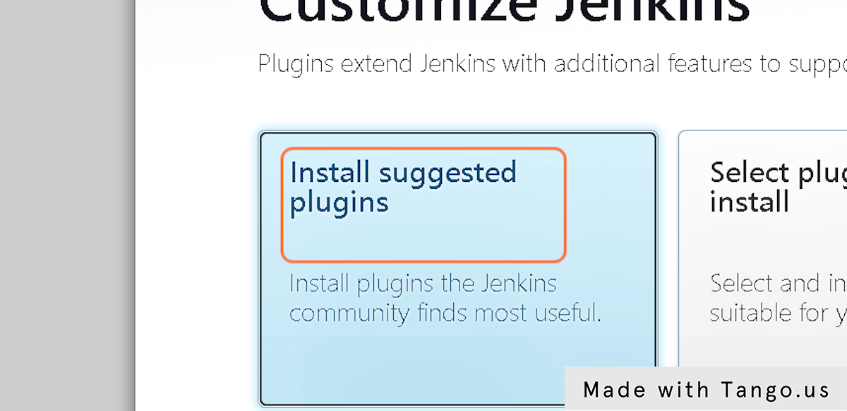

### **25. Fill the details**

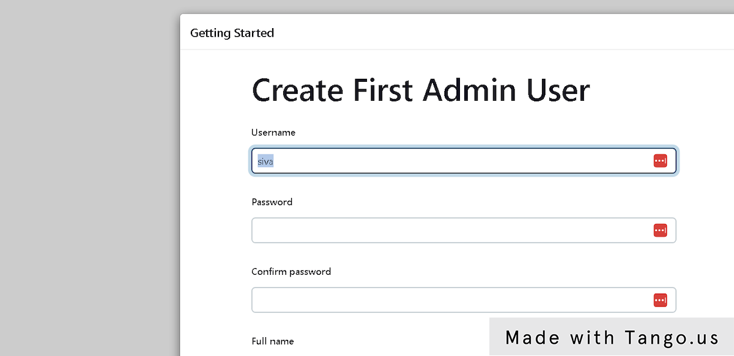

### **26. Fill in the details as per your wish**

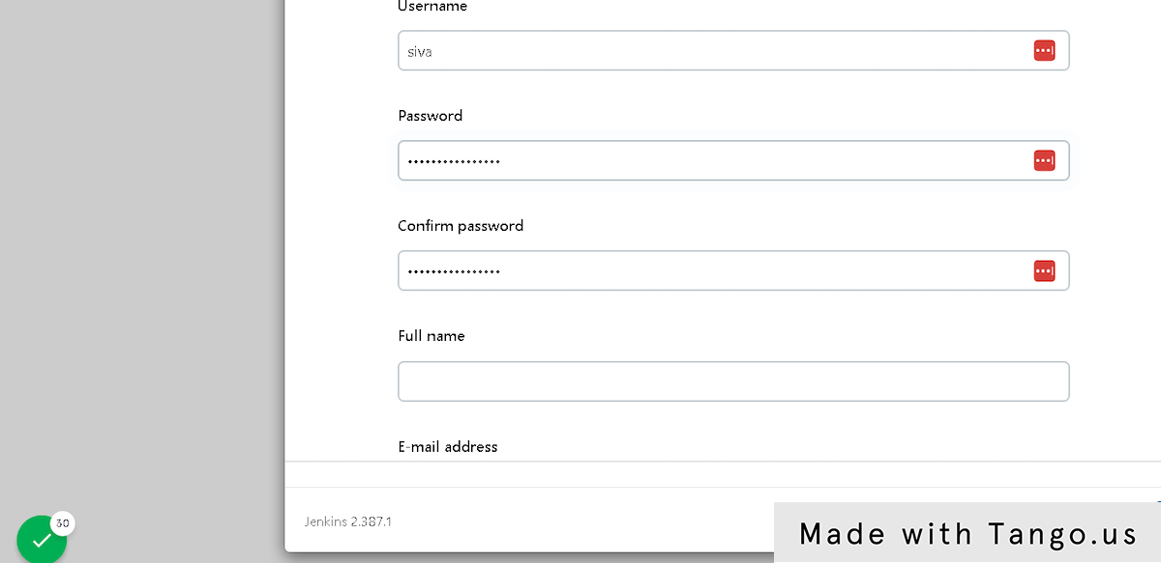

### **27. Click on Save and Finish**

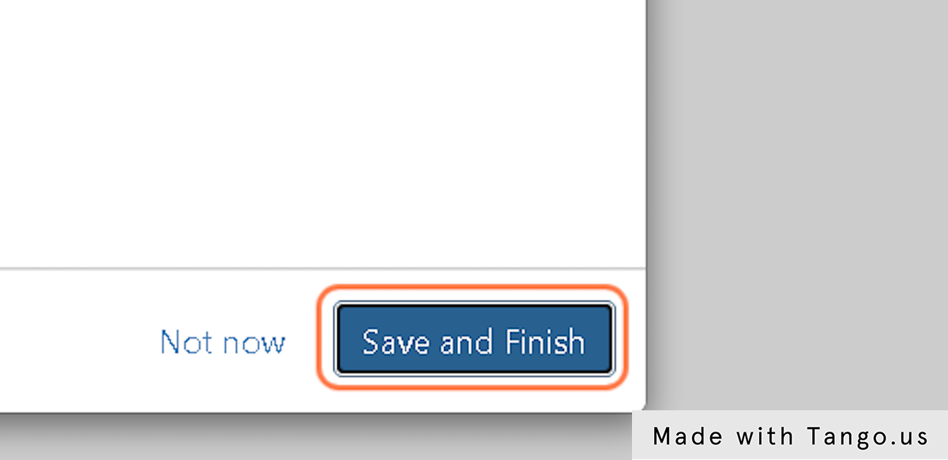

### **28. Click on Start using Jenkins**

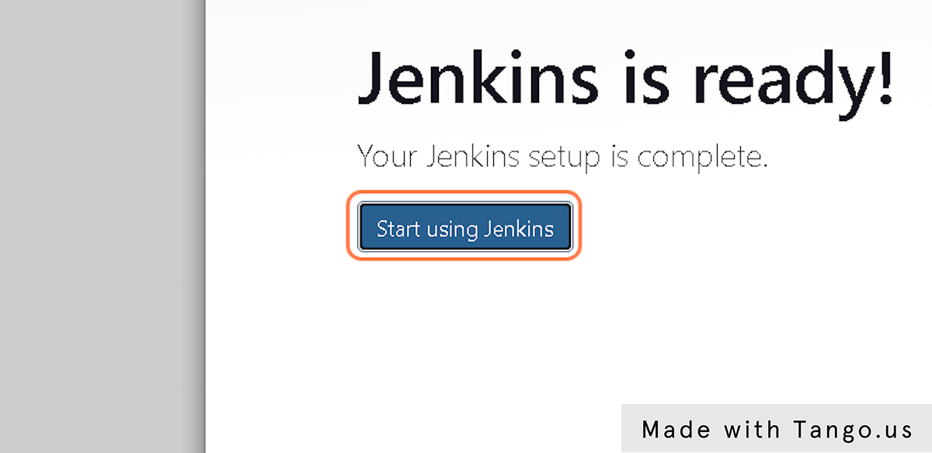

### **29. Click on New Item**

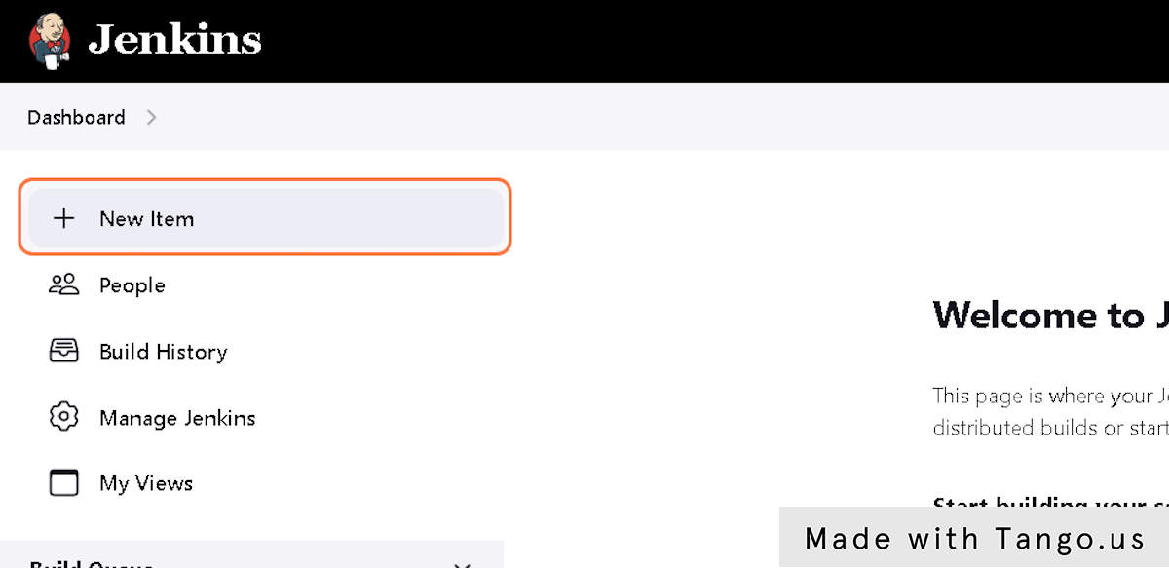

### **30. Type "testjob"**

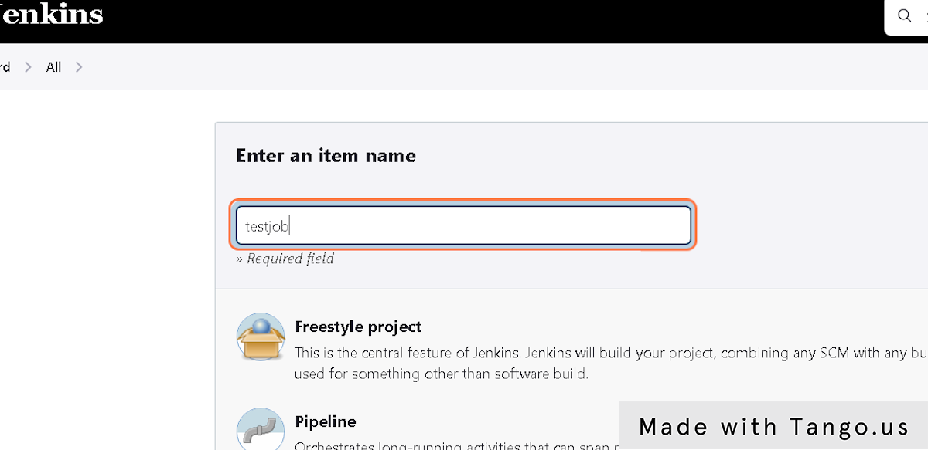

### **31. Click on any type of project you want to create**

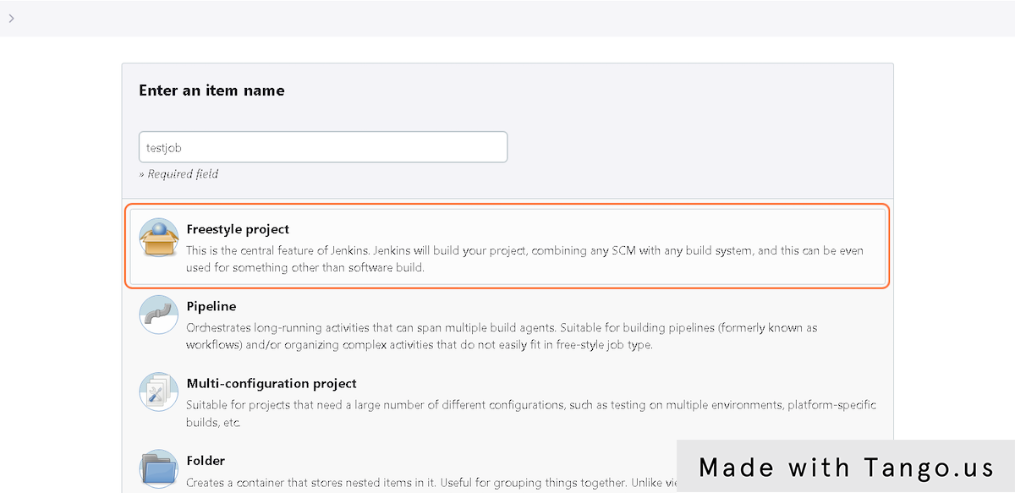

### **32. Click on OK**

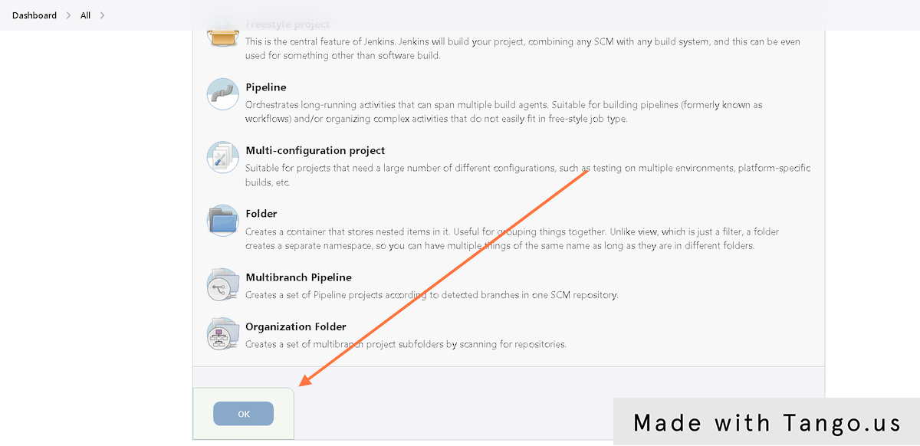

### **33. Click on Save**

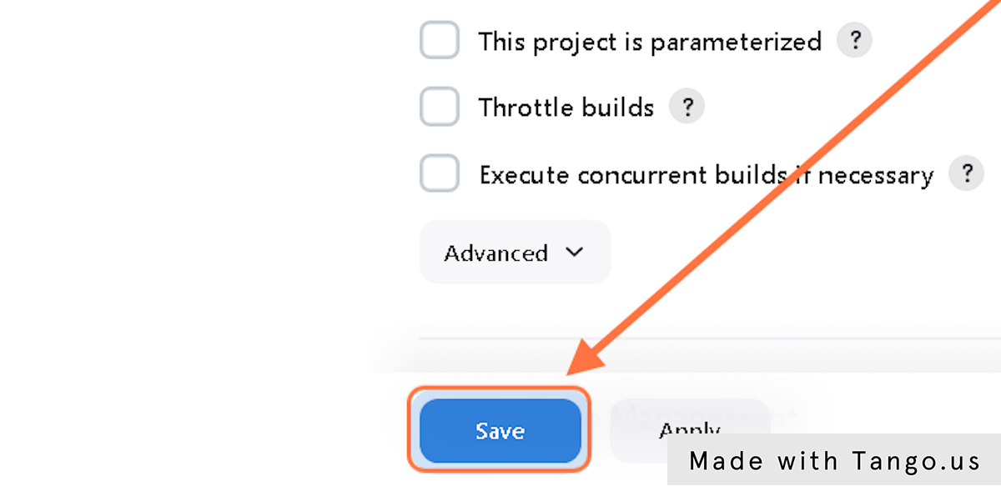

### **34. You can see your created testjob**

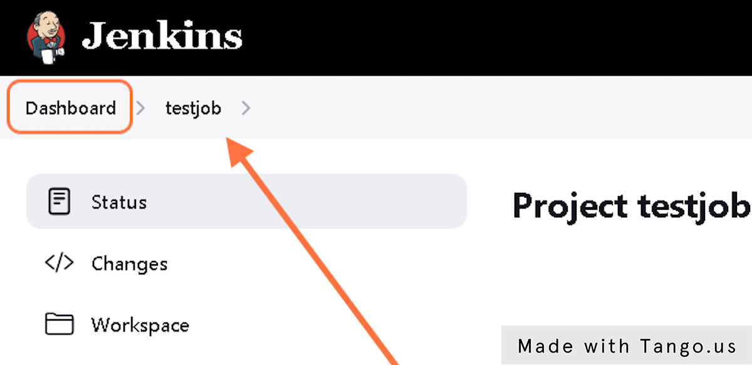

### **35. Since we already mapped the docker host path to the Jenkins files, even if we delete and provision another container. Still, we can see our last testjob as it is stored in our /root/jenkins_files.**

You have to log in again using old credentials, then you can see the testjob.

Hope everyone has a clear understanding of this. Thanks for reading...